***DOCKER – DEMO App***

**1.Create a Empty folder & Start the Docker-Engine.**

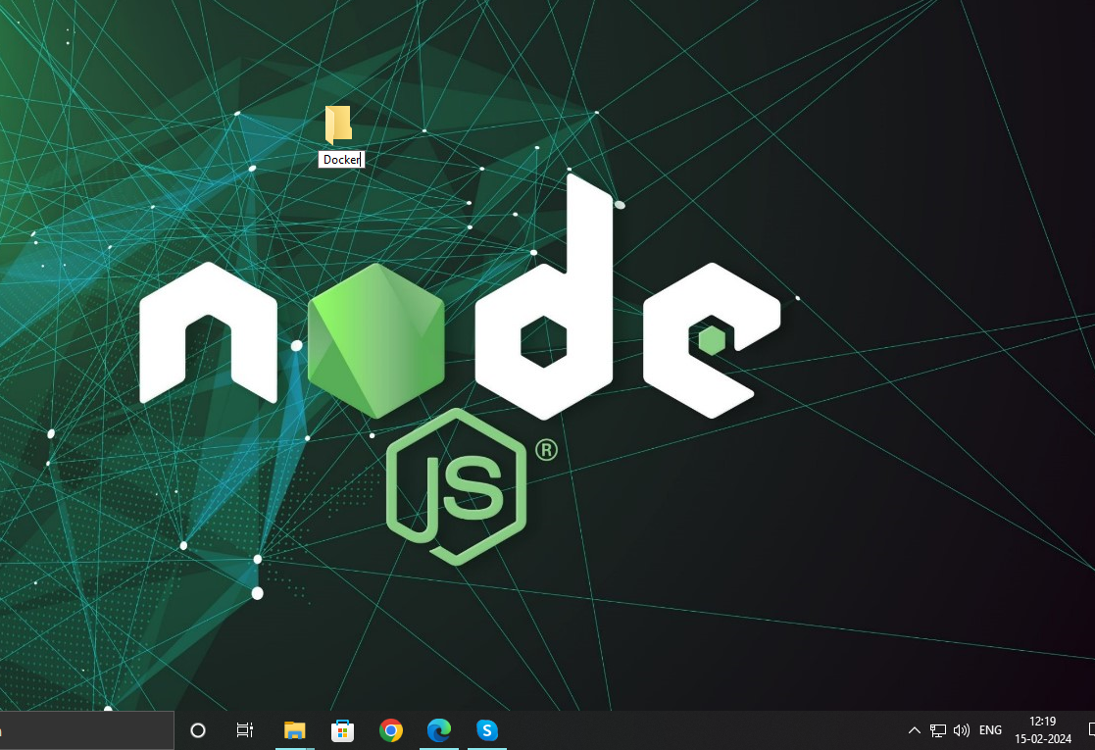

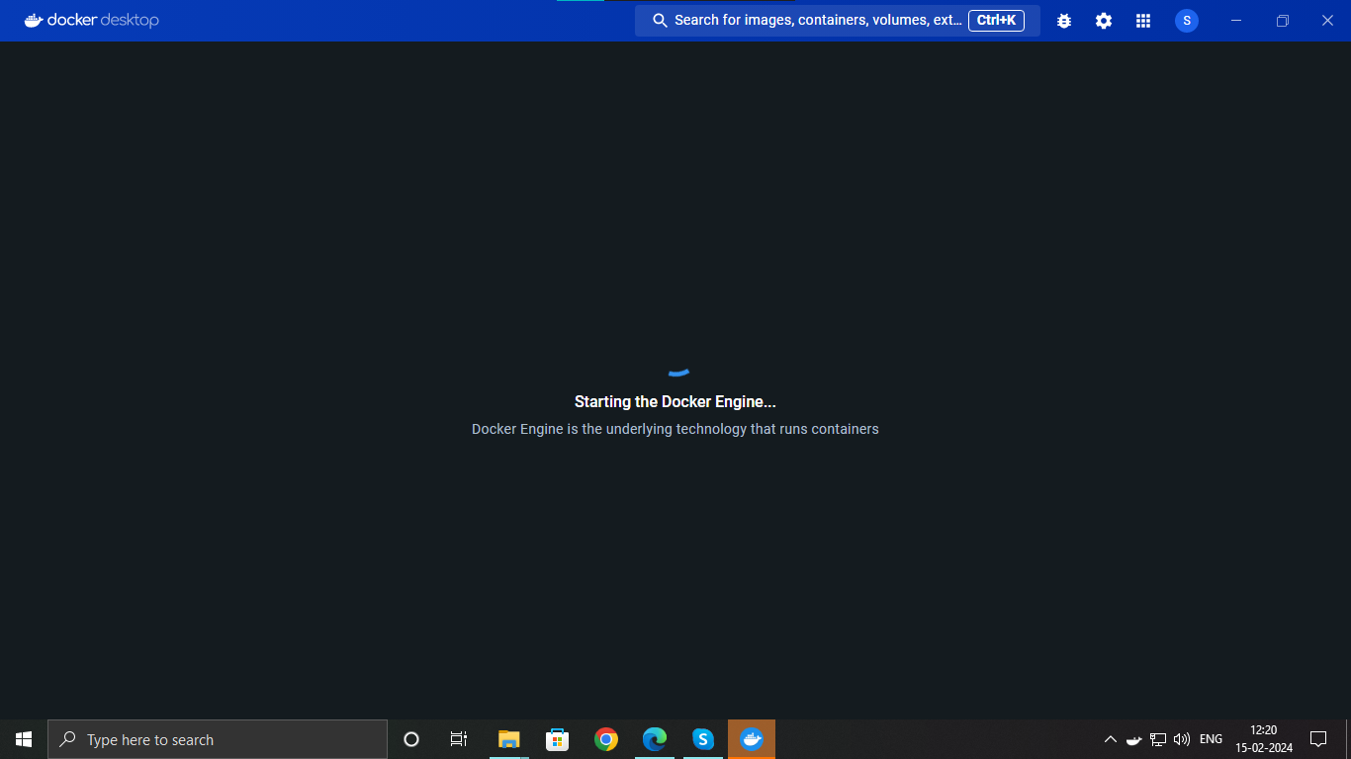

**Starting the Docker-Engine is mandatory and Ensure that You have GIT installed in Your Local machine.**

**2. Navigate to the created Folder open cmd terminal and type the git cmd to fetch the image source into your machine.**

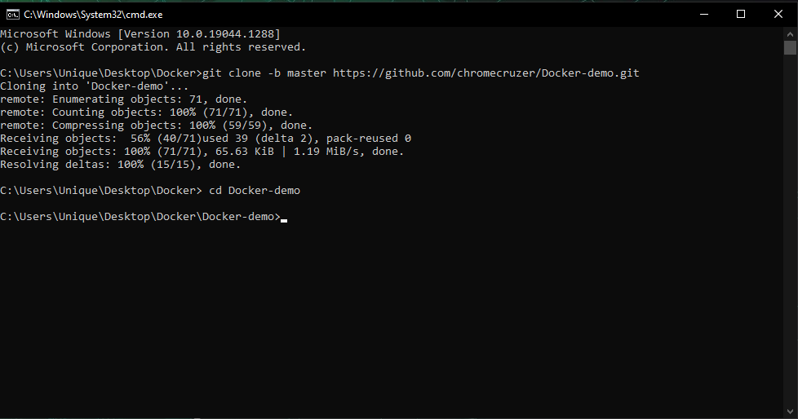

**git clone -b master https://github.com/chromecruzer/Docker-demo.git**

**Now go in to the >>Docker-demo folder**

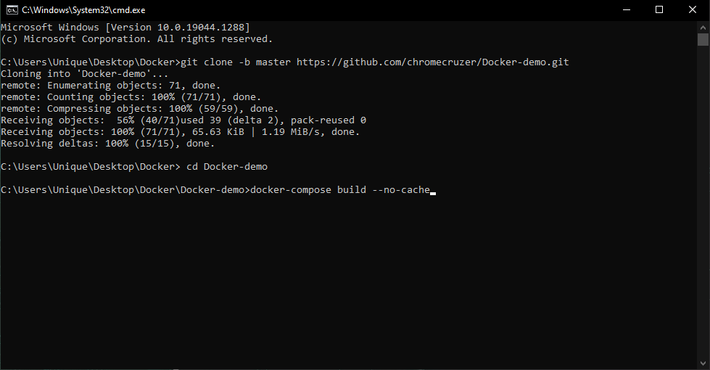

**cd Docker-demo**

**3. Type the Build cmd to Build the container.**

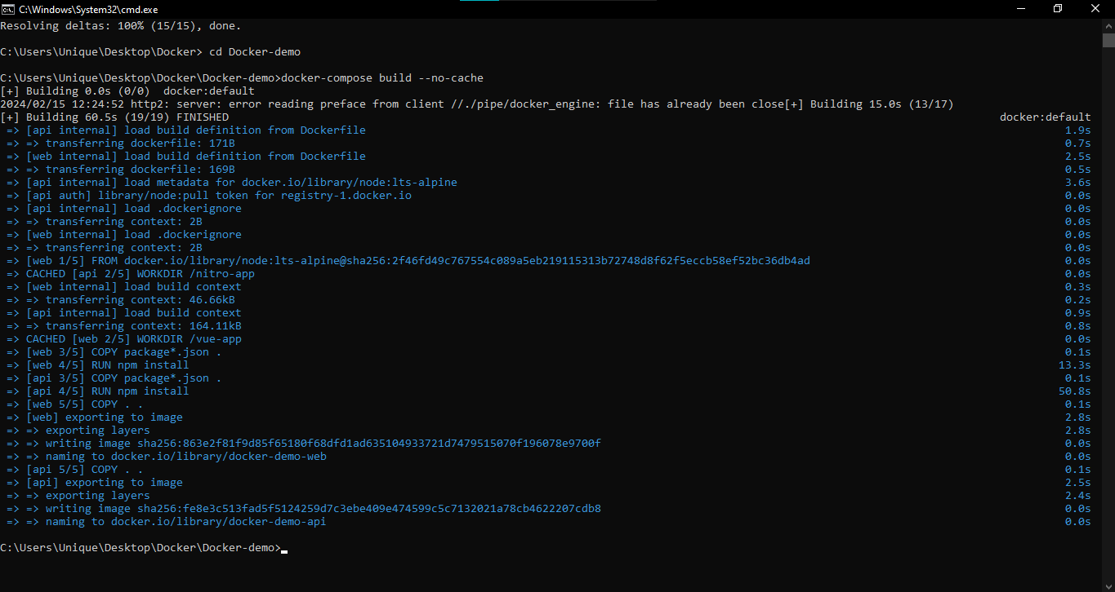

**docker-compose build –no-cache**

**4. Now type the Run cmd to start the container into your Local machine.**

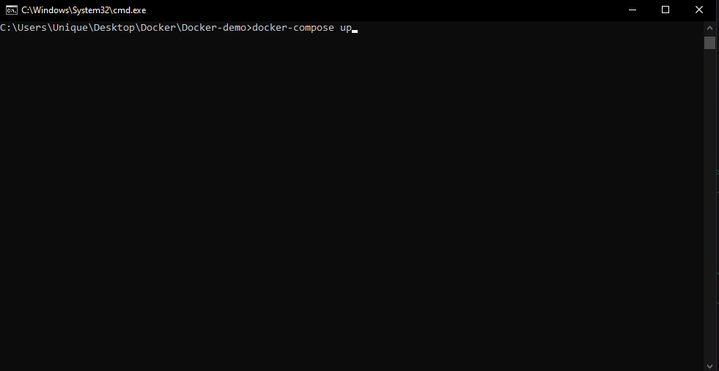

**docker-compose up**

**5. You can see the containers is Running successfully both API & WEB Services.**

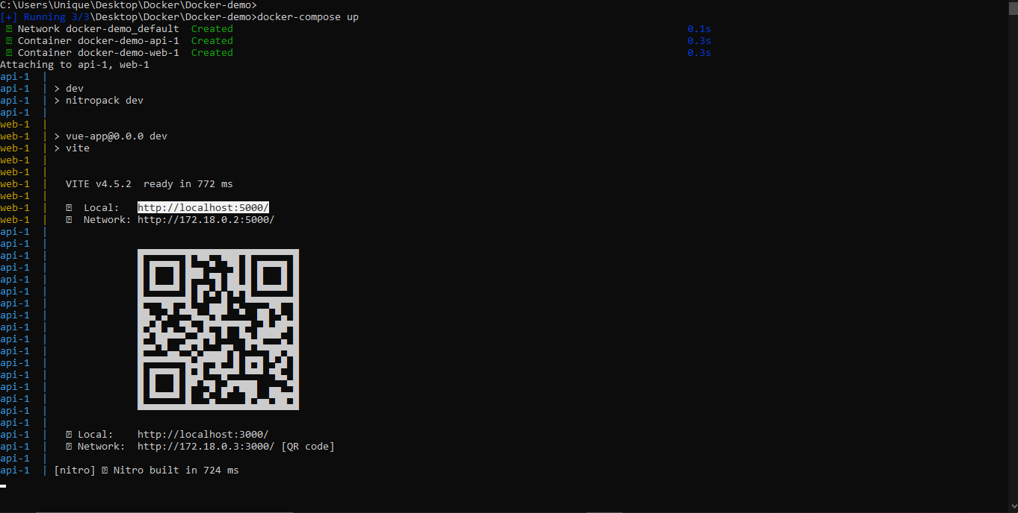

**6. Now go to browser (eg. Chrome or safari or firefox) and type this address http://localhost:5000**

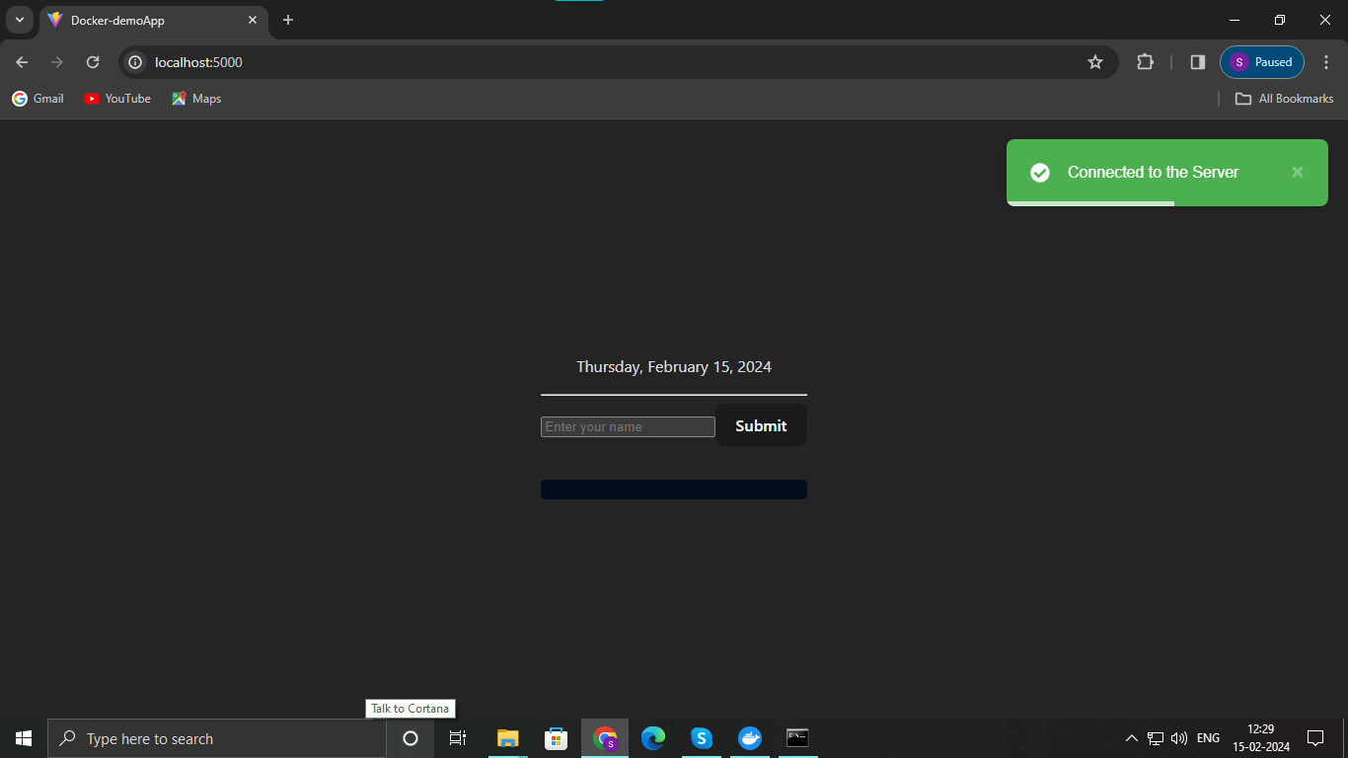

**The green Indication shows that the web is successfully connected to the api i.e. SERVER**

**7. Now the Vue-web is Ready to serve You can check by filling the form to send req to the server**.

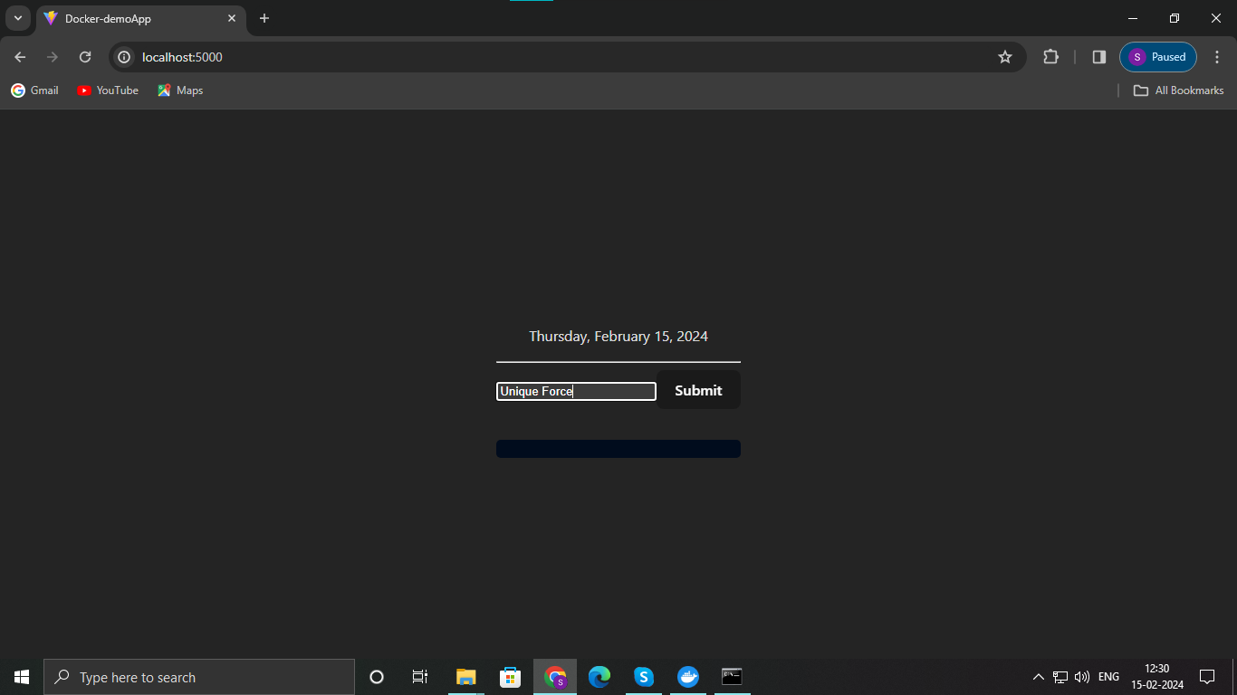

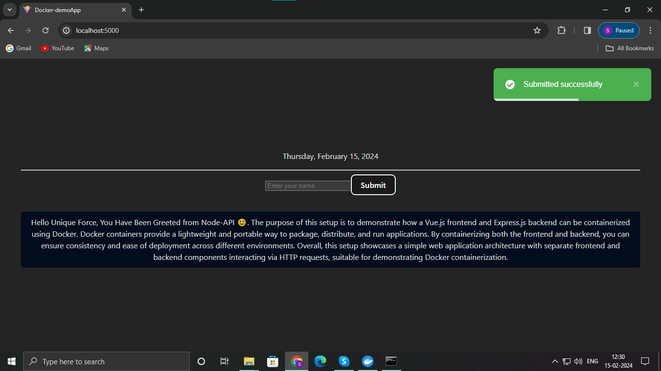

**The Green Submission Indicator shows that the req is successfully sent to the api.**

**8. Finally when done its important to Stop the containers by using the cmd docker-compose down for gracefull shutdown In a separate terminal because the previous terminal is under process.**

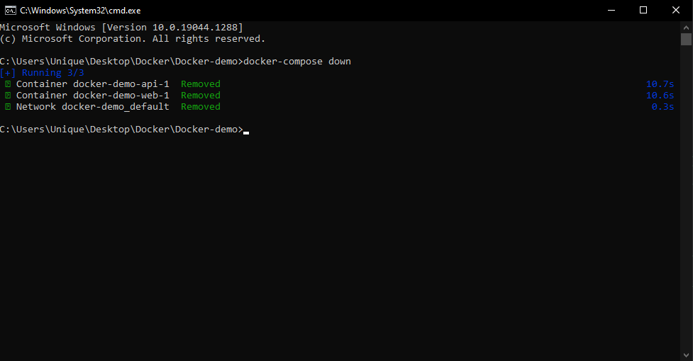

**docker-compose down**

WARNING !

Do Not Press CTRL + C to FORCE STOP the ENGINE it will lead to Loss of Data. Executing `docker-compose down` from a separate terminal ensures that the process is independent of any ongoing activities in the previous terminal, providing clarity and avoiding any potential confusion or interference. Once the build command is executed there is no need to rebuild again you can Run the container any time in your machine just by using the start command alone.